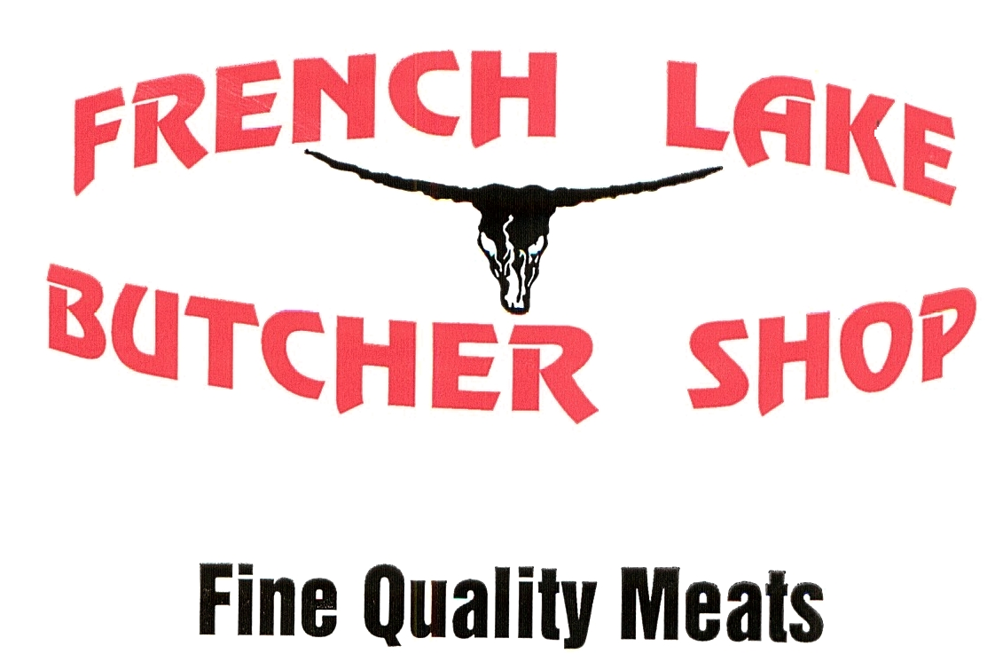
SMOKED SAUSAGES
Hickory Smoked North Country Sausage
Hickory Smoked Country Sausage
Hickory Smoked Kielbasa
Hickory Smoked Polish Sausage
Cheddar Cheese Wild Rice Sausage
Cured and Smoked Bratwurst
Hickory Smoked Jalapeno Cheese Bratwurst
Hickory Smoked Apple/Maple Wurst
Hickory Smoked Maple Breakfast Links
Natural Casing Wieners
French Lake Frank
Hickory Smoked Summer Sausage
Hickory Smoked Summer Sausage With Mild Pepper Cheese
COOKED SAUSAGES
Cooked Tailgater Beer Bratwurst
Ya'Mon Bratwurst (Tropical Flavored)

FRESH SAUSAGES
Southern Style Breakfast Sausage
Fresh Pork Sausage
Fresh Pork Breakfast Sausage Links
Chorizo
Fresh Fruit Variety Bratwurst
Hot Italian Sausage
Mild Italian Sausage
Fresh Polish Sausage
BACON
Hickory Smoked Sliced Bacon
Hickory Smoked Sliced Bacon Ends
Uncured Bacon
Raspberry Chipolte Bacon
Mexican Style Bacon
Hungarian Style Bacon
Burgundy Pepper Bacon
Bavarian Bacon
Cajun Flavored Bacon
HAM
Hickory Smoked Bone-In Ham
Hickory Smoked Bone-In Ham Steak
Uncured Hickory Smoked Bone-In Ham
Uncured Hickory Smoked Bone-In Ham Steak
Hickory Smoked BBQ Ham

MISC. SMOKED PRODUCTS
Blueberry Glazed Pork Butt
Hickory Smoked Pork Chops
Dried Beef
Cooked and Sliced Pork Roast

SNACK STICKS
Mild Jalapeno Cheese Waco Snack Sticks
Mild Waco Snack Sticks
Honey BBQ Waco Snack Sticks
BBQ Waco Snack Sticks
Hot Waco Snack Sticks
Blazin Chipolte Waco Snack Sticks
Bloody Mary Waco Snack Sticks
Teriyaki Waco Snack Sticks
Fiesta Waco Snack Sticks
BEEF JERKY
Beef Jerky
Pepper Beef Jerky
Bloody Mary Beef Jerky
Cajun Beef Jerky
Honey Beef Jerky
Teriyaki Beef Jekry
Hot Teriyaki Beef Jerky
BBQ Pork Jerky
BBQ Beef Jerky
BBQ Turkey Jerky
UNCURED ORGANIC SEASONED PRODUCTS
Uncured Pepperoni
Uncured Wieners
Uncured Summer Sausage
Uncured Andouille
Uncured Smoked Bratwurst
Uncured Cheddar Cheese Smoked Bratwurst
Organic Seasoned Fresh Sausages
Fresh Bratwurst
Mild Italian Sausage
Fresh Breakfast Sausage

